Employers Warm Up to Remote Workers Again: BioSpace Report
February 5, 2026 |
5 min read |
Angela Gabriel

Biopharmas are less focused on local job candidates and are more open to recruiting regardless of location, according to the new BioSpace employment outlook report. Even employers who prefer to hire locally would consider remote hires for some roles.
Although biopharmas prefer that employees live near the office, they’re more likely to hire remote workers this year than they were in 2025, based on the new BioSpace 2026 U.S. Life Sciences Employment Outlook report. Remote hiring took off during the COVID-19 pandemic, though in recent years, there was a shift toward having employees back in the office.
In a survey late last year of 136 professionals with insight into talent acquisition and/or workforce planning activities, 28% of respondents said that this year, they’ll recruit and hire remote candidates regardless of location. That number is up from 20% in the 2024 survey, when participants were asked about their 2025 hiring plans, and 16% in the 2023 survey. The 2023 findings signaled that the pandemic-induced remote hiring bubble had burst, as the percentage of respondents in 2022 who planned to recruit and hire remote candidates regardless of location hit 48%.
Two findings from the 2025 survey underscore employers’ willingness to once again look beyond people located near the office:
- The percentage of respondents saying they’re only focused on local prospects dropped year over year, from 24% to 20%.
- Even the majority (52%) of survey participants who would prefer to hire locally in 2026 would consider remote hires for certain roles.
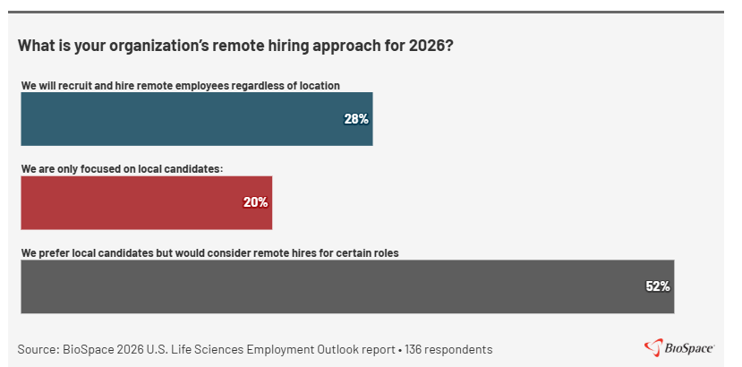
As to recent hiring practices, 36% of last year’s survey respondents estimated that in 2025, at least 26% of their new hires were remote, compared to 29% of 2024 participants. In contrast, from 2020 to 2023, 58% of respondents had brought in remote workers.
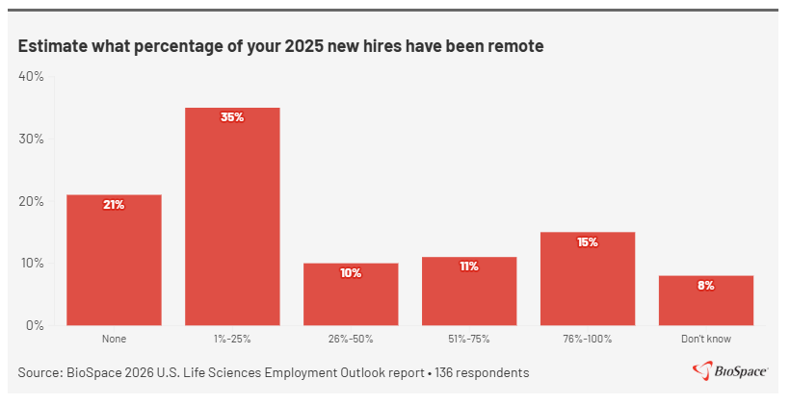

The Best Talent Isn’t Always Local
One reason employers are more likely to hire remote workers now than a year ago is likely concern about how prioritizing local prospects affects the candidate pool, based on the workforce planning survey. When asked if their organization misses out on candidates due to relocation requirements, 35% said yes.
Industry recruiting experts Molly Robb and Julie Heneghan agreed that concern about missing out on strong hires is a key reason employers are more willing to hire remote prospects. Robb, principal owner of MRSearch, an executive search and coaching boutique, told BioSpace it’s expensive when companies don’t have someone in a needed seat, so biopharmas are willing to be a bit more flexible to get core competencies they’re seeking.
Heneghan, president and founder of national life sciences staffing firm The Steely Group, shared a similar insight. She told BioSpace when considering candidates, Steely’s clients are increasingly weighing performance and speed to hire over physical location, especially in roles that aren’t lab related.
“A lot of our client companies will say that they learned during the market downturn that limiting searches geographically can slow hiring or lead to maybe weaker talent matches,” Heneghan said. “These companies, most all of our client companies, want access to highly specialized talent. Some of that just may not exist locally.”
That said, Heneghan and Robb agreed that employers prefer to start the recruiting process with local searches before expanding it to hybrid and then remote candidates. Robb also noted that company size is a factor in organizations’ willingness to hire fully remote workers. Larger biopharmas are more flexible, she said, while startups prefer people being in the office at least three days a week, which helps with onboarding, making connections and building a culture of trust.

Desire for Remote Work Remains But Dips
Biopharma employers’ increased willingness to hire remote candidates is good news for those seeking jobs that aren’t office based. Having that flexibility was a high priority for about one-third of the 1,499 biotech and pharma professionals who responded to a career planning survey late last year that informed the BioSpace employment outlook report. When asked what’s important to them in their next job, 32% of employed/contract and 31% of unemployed respondents said remote work options were very important.

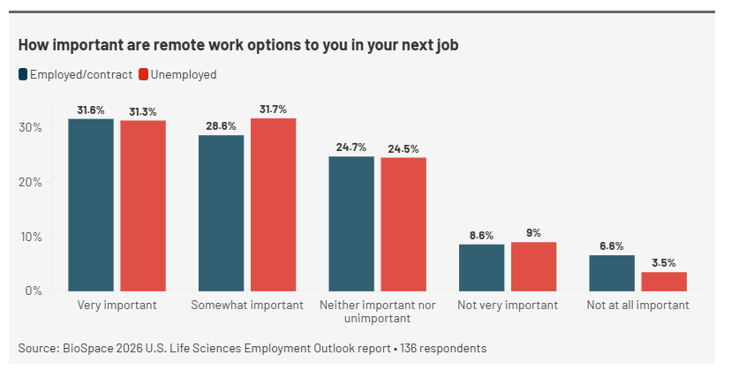
Several survey comments highlighted biopharma professionals’ desire to work remotely, as well as the difficulty in making that happen.
- “I have worked remote for 6 years and do not want to be going back to the office 5 days/week. I am just as productive (if not more) working remotely.”
- “Although remote work is a viable option for me, many remote positions are highly competitive.”
- “Lack of remote opportunities will deter great talent from applying to roles.”
- “Drive back to office environment has hurt me personally, though I’m generally in favor (at least not actively against) those moves. Though - it hurts me because I’m not in / near HQs -- and do not really want to move given family impact (and am looking outside of biopharma as a result).”

While some biopharma professionals feel strongly about workplace flexibility, others are placing less importance on it now than they did a year ago, based on the 2025 survey. While 32% of employed/contract respondents said remote work options were very important to them in their next job, that number was down from 38% in 2024. Similarly, fewer unemployed participants said working remotely was very important in 2025 (31%) than in the year prior (36%).
In addition, the percentage of respondents saying it was not very or not at all important went up from 13% to 16% year over year for employed/contract workers. It remained nearly the same for unemployed biopharma professionals, at 11% in 2024 and 12% in 2025.
One reason some are prioritizing remote work less is the job market favors companies, not candidates, according to Robb. She said it makes sense that biopharma professionals are willing to comply and acquiesce more on where they work not only because they need the income but also because there aren’t enough jobs out there.
Heneghan agreed that market conditions play a role in decision making and noted that candidates are prioritizing stability considering continuing industry layoffs—the number of affected employees increased significantly in 2025—and industry contraction. In addition to job stability, she said, candidates are focusing on factors including strong pipelines, career growth opportunities, competitive compensation and company culture.
The career planning survey supports that assessment. Among employed/contract workers, the top three factors respondents identified as very important to them in their next jobs were growth opportunities (65.6%), work-life balance (65.2%) and company is financially stable (64.6%). Among the unemployed, the top three were company is financially stable (56.2%), work-life balance (55.4%) and benefits (53.7%).
“Remote flexibility is still valued,” Heneghan said, “but fewer candidates are willing to reject a role solely due to on-site expectations or even hybrid expectations, whereas a few years ago, just flat out, a lot of people would say, ‘If it’s not 100% remote, I’ll take a pass,’ because they had so many other options.”

